January 3, 2013

Caspian Lake’s Public Beach Ownership: A Surprising History

By

H. Clay Simpson

The proposed sale of Caspian Lake’s public beach, outlet dam and boat ramp by the Town of Hardwick to the State of Vermont’s Fish and Wildlife Department has raised concerns about the future management of public access to one of Vermont’s most pristine bodies of water. Many people have asked how the Town of Hardwick came to own this important piece of property located in the neighboring community of Greensboro.

Hardwick’s ownership can be traced back to the 1920s when it was a building granite center. Quarries located in the nearby town of Woodbury provided granite that was transported to finishing sheds via the Hardwick Woodbury Railroad. There was a growing need for electricity to power granite saws and polishers. In 1923 the Woodbury Granite Electric Company searched the area for sources of hydroelectric power. The *Hardwick Gazette* reported in June 1923 that a survey of potential waterpower at Caspian Lake had been completed. The lake flow from the intake gate to low ground below a mill on the outlet stream was considered an excellent source of waterpower. Plans were developed to dam the outlet of the lake and produce electricity.

Hardwick Purchases the Caspian Lake Outlet, Nearby Beach and Water Rights

On July 23, 1923 the *Gazette* reported “there will be a special Village of Hardwick meeting to see if the Village will vote to purchase any or all of the properties and rights situated on Caspian Lake, Greensboro, VT, on the stream and the outlet.” After the meeting approved the plan, Hardwick purchased an option to buy water rights from the Perrin Brothers who used the outlet stream for a blacksmith and woodworking business, but the option was apparently never exercised. A month later the Village signed a deed to acquire the Caspian Lake outlet and water rights from John H. Barrington, who operated a water-powered gristmill on the outlet stream. His outlet and nearby property included very little, if any, of the lakeshore that now forms the swimming beach and boat access.

Barrington made an attractive offer to sell this property for one dollar ($1) and other considerations based upon his need for electric power from Hardwick’s proposed hydroelectric dam. He deeded “all of the water and power rights and privileges owned and controlled by me in Greensboro in connection with the waters flowing from Caspian Lake . . . including gates at the outlet of said lake and all of my interest in the dam and shoreline bordering the outlet and . . . and rights to the brook flowing from the outlet.” As a “further consideration the Village of Hardwick shall furnish me, or my assigns electric power at the rate of two cents ($.02) per kilowatt for the term of five years from the date of this deed, said current to be furnished only to my gristmill for said rate.”

But instead of building a dam, Hardwick elected to use lower cost power offered by the People’s Hydro Electric Company in Montpelier. The hydroelectric project at Caspian was never implemented. By 1927 granite shipments began to decline in Hardwick, and the Hardwick Woodbury Railroad was closed in 1934 although some sheds continued to operate until after World War II.

In the summer of 1926 John Barrington and several other Greensboro businessmen invested $50,000 in “Highland Estates,” a real estate venture in Greensboro. They offered for sale seventy-eight Caspian Lake camps to be equipped with electric and water service (covering the beach front area now owned by Highland Lodge).[1] By 1930 only a few sites were sold before a real estate collapse began nationwide.

Hardwick Purchases the Caspian Public Beach in 1927

Hardwick found another use for its Greensboro property. The people of both Hardwick and Greensboro without camps on the lake began to use the beach site near Hardwick’s outlet for bathing and recreation. In January 1927, the Village of Hardwick acquired the lakeshore southwest of the outlet which now forms the swimming beach and boat access. The *Gazette* reported that on a cold snowy Monday evening at the Memorial Building “the very few voters who attended instructed the Trustees to purchase what was known as the Cuthbertson Lot situated between the highway and a water gate at Caspian Lake” Archie Cuthbertson deeded Caspian’s boat ramp and public beach to Hardwick on June 16, 1927 for “one dollar and other good and valuable considerations.” The other considerations, if any, are not known.

Archie Cuthbertson was a descendent of a Scottish family who immigrated to Greensboro. He inherited with his brother a valuable family store specializing in dry goods (later purchased by Willey’s Store and attached to offer hardware). But at the time of this sale he had suffered financial setbacks as a partner of John Barrington in Highland Estates, and his store would be heavily damaged later in 1927.

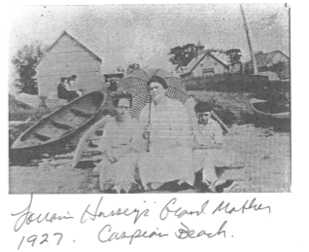

Relations between summer camp owners and the Village of Hardwick became difficult in 1927. During the wet summer several Greensboro camps were flooded and the owners claimed damages due to Hardwick’s water release policies. A court case in July, Turrell vs. the Village of Hardwick, required Hardwick to make predetermined releases of water in the future for each season of the year.

In October the great flood of 1927 began. The small dam at the outlet gave way and buildings near the swollen stream including the Cuthbertson’s store and Barrington’s gristmill were flooded. There was a general fear in Hardwick that the entire shore of Caspian Lake might break away letting the water in the lake flow down the valley to flood Hardwick. A later investigation showed this part of the eastern shoreline to be solid rock.

A committee of camp owners in Greensboro was formed to work with Hardwick in the future to monitor the water level. This group was incorporated as the Greensboro Association in 1934. In 1937 Hardwick’s Caspian beach property was leased to Greensboro for three years, but the lease was not renewed.[2]

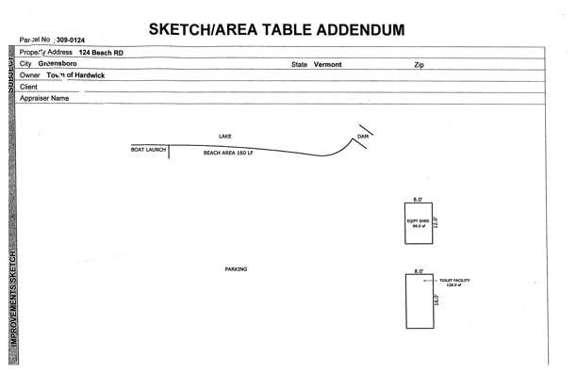Sketch of the Caspian Boat Ramp, Public Beach and Outlet

In recent years the communities of Hardwick and Greensboro worked successfully with the Greensboro Association (with over 550 members from both towns) to manage Caspian Lake’s public beach access, water quality and boat access. As a result of their efforts this small lake has been rated one of the cleanest and most pristine bodies of water available for public use in the US.

Sources: Clive Gray (Copies of deeds and other background information from the files of the Greensboro Town Clerk), Lorraine Hussey (*Hardwick Gazette* articles and the photo of her grandmother on the beach in 1927), Allen F. Davis (valuable background details about the history of Hardwick), “Hardwick Electric Department’s Land Holdings in Greensboro” an opinion of title by Deborah T. Bucknam, Esq. (Beach File at Greensboro Town Clerk’s office, June 6, 1989), *The History of Greensboro, The First Two Hundred Years* (1990, Greensboro Historical Society).

Note about the author:

Clay Simpson is a Trustee of the Greensboro Historical Society and a Member of the Board of the Greensboro Association. He is a regular contributor to the *Hazen Road Dispatch*.

1. “How Highland Lodge Got Its Name,” Patricia A. Billingsley, *Hazen Road Dispatch*, Summer 2011.
2. In 1988 the Village of Hardwick was merged into the Town of Hardwick.