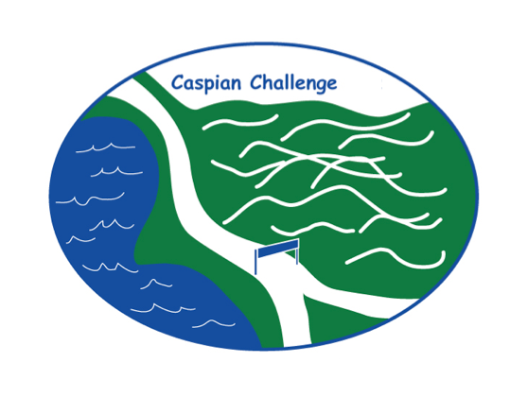
THANK YOU to Hillcrest Nursery, Jasper Hill, Miller’s Thumb, MVCC, Skida, and Willey’s!
THANK YOU to Becky Arnold Oils, Greensboro Garage, Highland Lodge, and Hill Farmstead!

THE CASPIAN CHALLENGE!
SUNDAY, JULY 25, 2021
REGISTRATION ONLINE & 8-9am on 7/25 at Ball Field
SELF-TIMED RACE BEGINS AT 8:30 am; RUNNERS MAY ALSO START LATER

The 10th Annual Caspian Challenge lake run/5K, sponsored by the Greensboro Association, is open for registration now! Join us for a morning of community support and fun activity—but please bring masks (for start and finish), a watch to time yourself, and be conscious of distancing.

Proceeds from this year’s Caspian Challenge have been designated by the GA board to support Greensboro’s Walk/Bike Task Force. Whether you run, walk, or just come as a cheering squad – we want you to be distanced but involved!

For more information, or to register starting June 1, go to greensboroassociation.org
Pre-register online – $15.00 donation suggested.

The race will again be self-timed this year, with participants reporting their times online after the race. Prizes will be awarded by a random drawing of registered participants; prize pickup at end of race.!

